Experiment - 07
Integrating a Zoho Creator Application with Another Zoho Service Using Connections and APIs
SAI PRANAV B.V
241401088 CSBS
AIM
To integrate the Patient Appointment & Scheduling Management application developed in Zoho Creator with Zoho CRM using an OAuth connection, workflow automation, Deluge scripting, and the Zoho CRM API.
OBJECTIVE
The objective of this experiment is to establish an authenticated connection between Zoho Creator and Zoho CRM and automatically transfer selected appointment information from the Creator application to Zoho CRM when a patient successfully submits an appointment request.
PROCEDURE
Phase A: Create and Authorize the Zoho CRM Connection
1. Open the Patient Appointment & Scheduling Management application in Zoho Creator.
2. Navigate to Develop → Microservices → Connections.
3. Select Create New.
4. Select the Zoho CRM connector.
5. Configure the connection using OAuth authorization.
6. Provide access to the required Creator application.
7. Authorize the connection using the Zoho account.
8. Complete the connection creation process.
9. Verify that the connection is displayed as Connected.
10. Note the connection's Link Name, which is required when calling Zoho CRM from Deluge.
The connection provides authorized access between the Creator application and Zoho CRM.
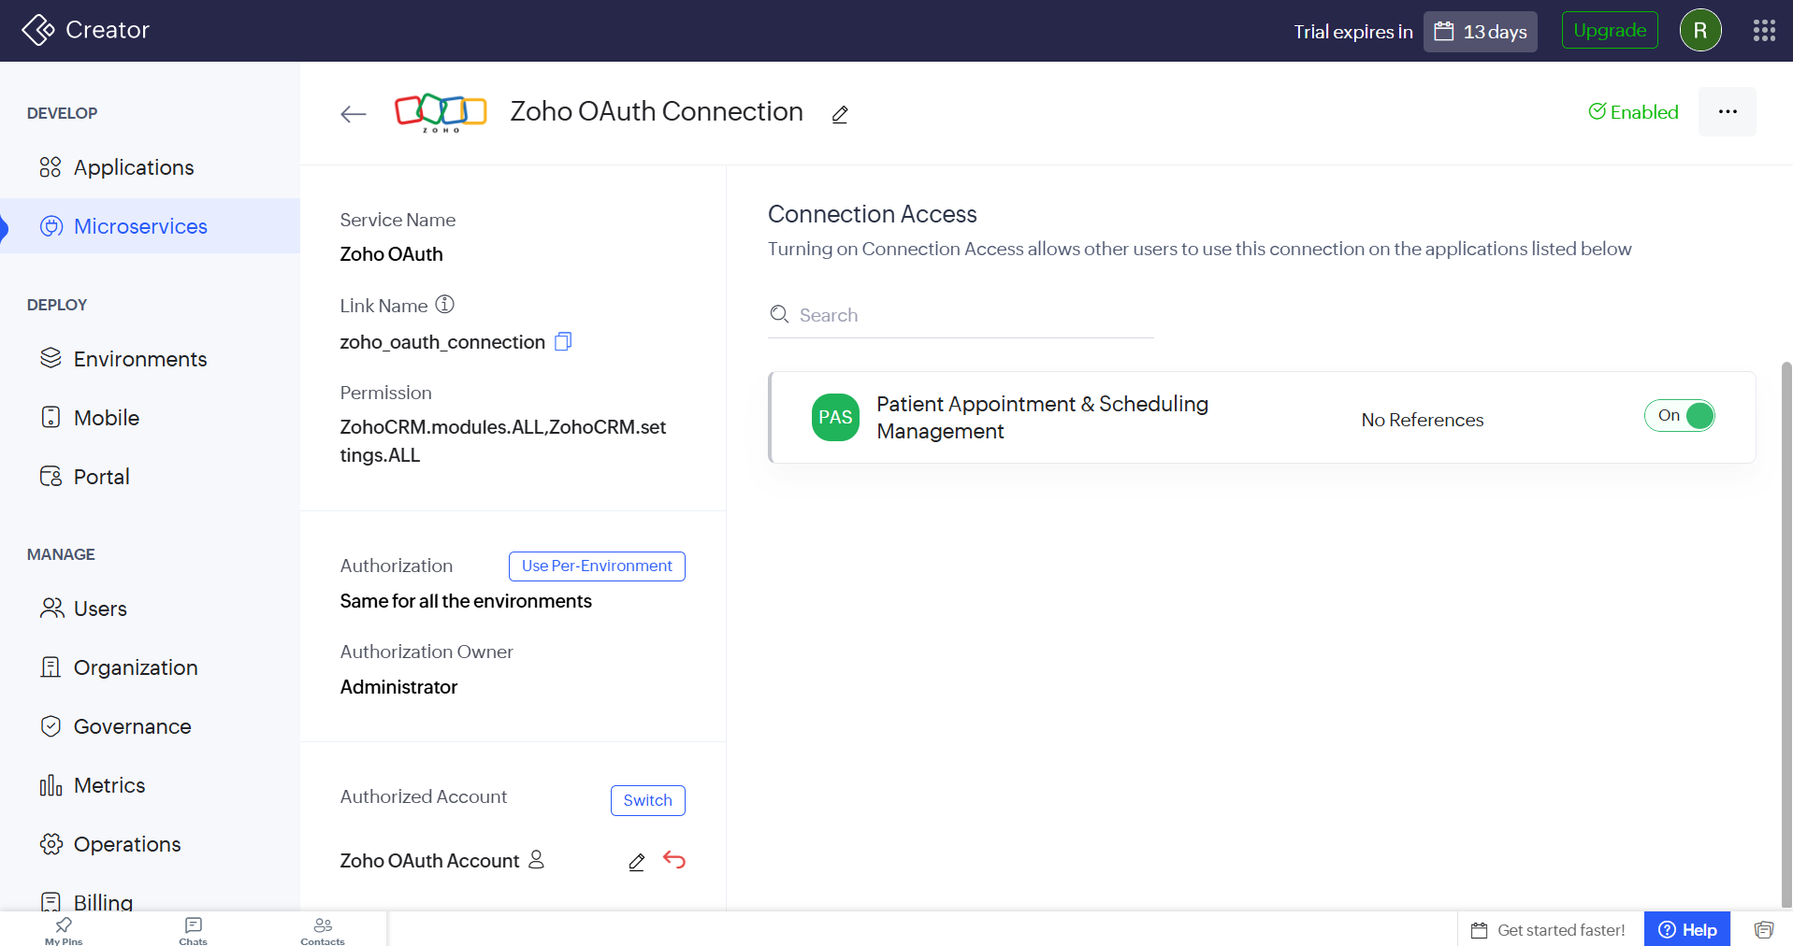
Screenshot 1 — Authorized Zoho CRM OAuth connection with its Link Name in Zoho Creator

Phase B: Create the Integration Workflow
1. Open the Patient Appointment & Scheduling Management application and navigate to Workflows.
2. Create a new workflow for Appointment_Booking_Form.
3. Set the workflow event to Record Event → Created.
4. Select Successful form submission as the form event.
5. Name the workflow send_appointment_to_crm.
6. Configure the workflow to run whenever a successful appointment submission occurs.
7. Add a Deluge Script action.
This allows the integration code to execute automatically whenever a patient successfully submits an appointment.

Phase C: Configure the Deluge API Integration
The Deluge script creates a map containing selected appointment information and sends it to the Leads module in Zoho CRM. The following fields were transferred:
Zoho Creator Field | Zoho CRM Field
Patient Name | Last Name
Email Address | Email
Contact Number | Phone
Fixed value: Patient Appointment | Company
Fixed value: Patient Appointment Booking | Lead Source

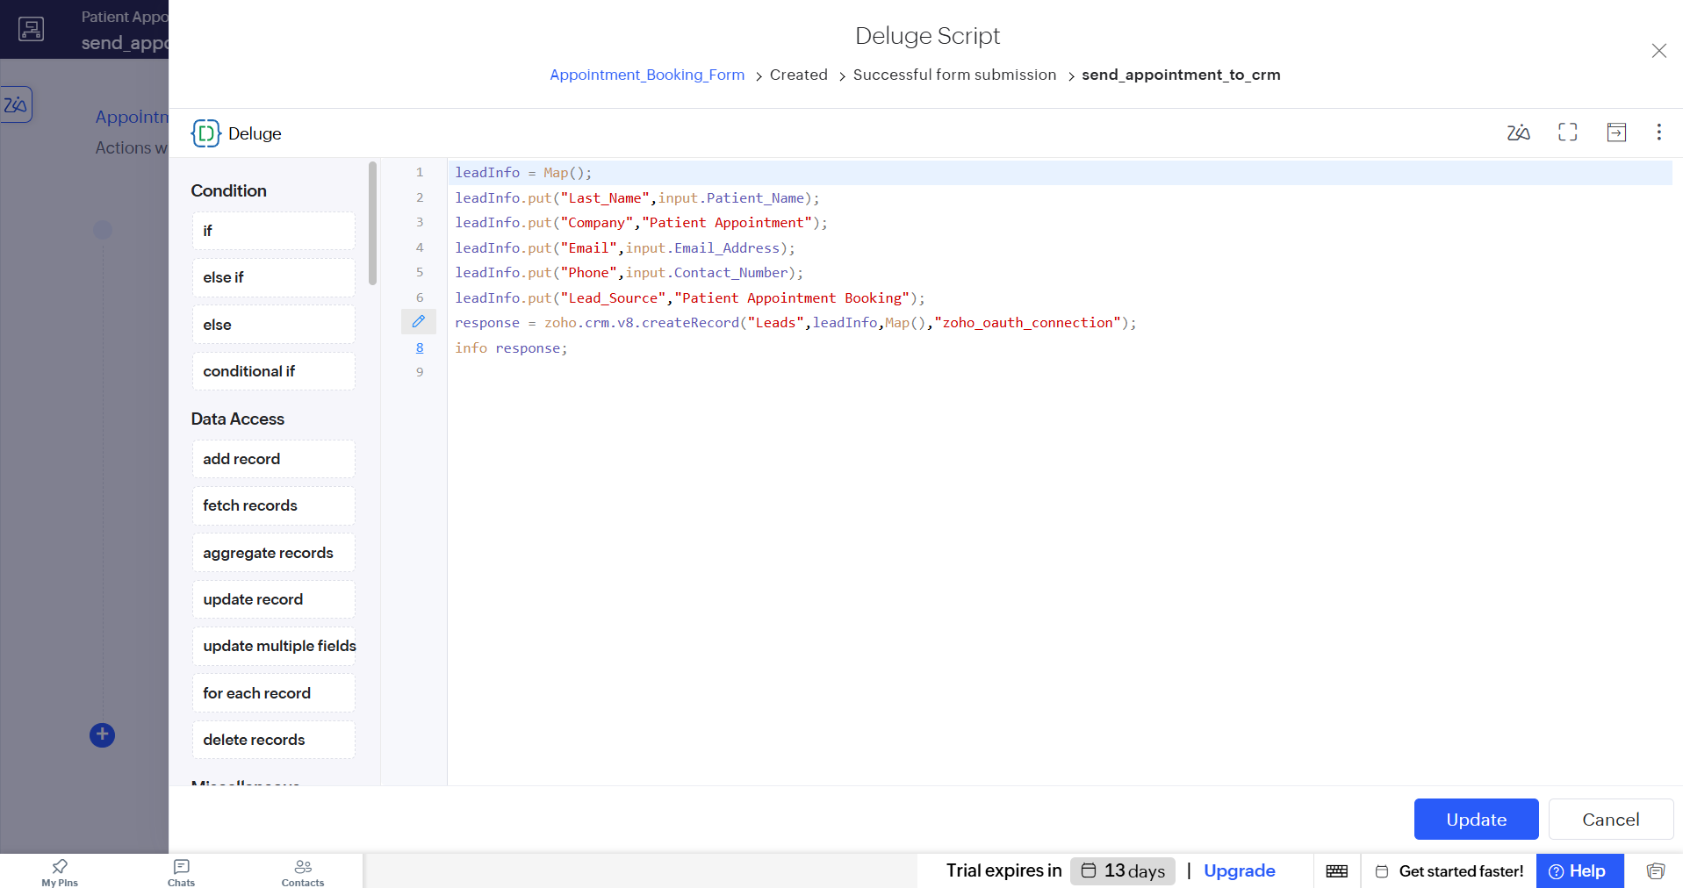
Screenshot 2 — Deluge script containing the zoho.crm.v8.createRecord() call and the authorized Zoho CRM connection

Phase D: Test the Integration
1. Save the Deluge script.
2. Save and enable the send_appointment_to_crm workflow.
3. Open the live version of Appointment_Booking_Form.
4. Enter valid appointment information.
5. Submit the appointment form successfully.
6. The Creator workflow executes automatically.
7. The Deluge script sends the selected information to Zoho CRM.
8. Open the connected Zoho CRM application.
9. Navigate to the Leads module.
10. Verify that a new Lead corresponding to the submitted appointment has been created.
OUTPUT
The following outputs were obtained:
1. Zoho CRM OAuth connection was successfully created and authorized.
2. The connection was made available to the Patient Appointment & Scheduling Management application.
3. The send_appointment_to_crm workflow was created and configured for successful appointment submissions.
4. A Deluge script was added to the workflow.
5. The Zoho CRM API was invoked using the authorized connection.
6. A test appointment was submitted successfully through the Creator application.
7. The corresponding Lead was automatically created and displayed in Zoho CRM.
The final results of the integration are shown below.
1. Successful Appointment Submission
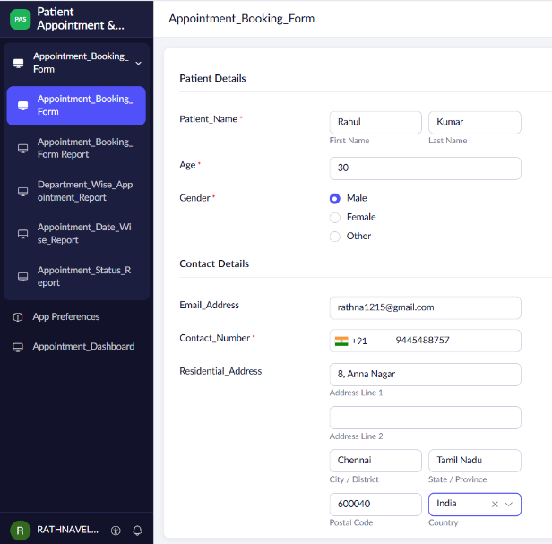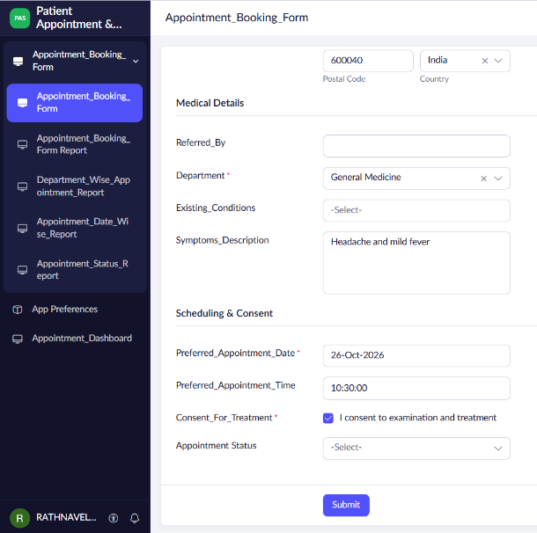
Screenshot 4 — Test appointment submitted successfully through the live Creator form

2. Created CRM Lead
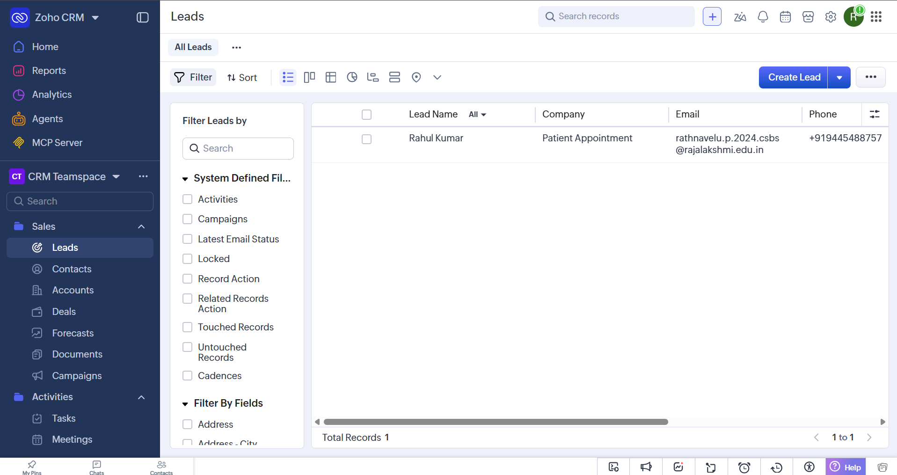
Screenshot 5 — Lead automatically created in the Zoho CRM Leads module

RESULT
The Patient Appointment & Scheduling Management application was successfully integrated with Zoho CRM using an OAuth connection, workflow automation, Deluge scripting, and the Zoho CRM API. When a patient successfully submits an appointment request, selected patient/contact information is automatically transferred from Zoho Creator and a corresponding Lead is created in Zoho CRM. Thus, the integration between the Zoho Creator application and another Zoho service was successfully implemented and verified.

